**ACTION ITEMS STATUS REPORT**

|  |  |
| --- | --- |
| **Report Date** | **Project Name** |
| **May 2022** | **Automated In-Plant Line Inspection Reporting System** |

|  |  |  |  |  |
| --- | --- | --- | --- | --- |
| **Task, Actions Items, Milestones, Deliverables Overview** | | | | |
| **Task/Action Items / Milestones** | **Actions/ Solutions Performed** | **Status** | **Date Completed** | **% Complete** |
| * Create a page for the function of POSMD | * Dashboard page * Account page * Meat Establishment Page * Daily Receiving of food Animals | On progress | 05/16-31/2022 | 100 % |
| * Create a page for the function of POSMS | * Dashboard page (Region) * Account page (Region) * Meat Establishment Page (Region) * Daily Receiving of food Animals (Region) | On progress | 05/16-31/2022 | 100 % |
| * Create a page for the function of Meat Inspector Officer | * Dashboard page * Meat Establishment Assigned * Ante-mortem, Post-mortem Inspection page |  | 05/16-31/2022 | 100 % |
| * Database structure | * Gathering some Data for the database structure | On progress | 05/16-31/2022 | 80% |
| * Process Analyzation | * Interviewing the end-user for the confirmation of the process | On progress | 05/16-31/2022 | 75% |
| * Budgetary Requirements | * Discussion about the budgetary requirements with IT Unit / POSMD using FORM C | On progress | 05/16-31/2022 | 100% |
| * Meeting with the Project Manager, Process Owner and System Development Team | * Discussion about the progress of AIPLIRS and talk about the process created in IT terms including Database Structure, Process flow manual, Swimlane, Work Breakdown Structure | Done | 02/24/2022 | 100% |
| * Approved proposal process | * Swimlane, Database Structure, Output needed to be generated by the system | On progress | 05/16-31/2022 | 80% |
| * Creating a Page Prototype for the debugging of Database structure to meet the system requirement | * Page Created for the Meat Establishment Daily Receiving * Page created for the Meat Inspector | On progress | 05/16-31/2022 | 70% |
| * Creating a SIPOC for the mapping of Manual Process | * Mapping the process flow from Meat Establishment to Meat Inspector Officer to POSMS to POSMD | For approval | 05/16-31/2022 | 100% |
| * Initial presentation for the Process flow of AIPLIRS | * Discussion of the process flow created on system and presented to the process owner | Completed | 05/05/2022 | 100% |
| * Agreements for the revision of the system and additional | * Creation of MIO, ME and Meat Dealer accounts in the system. * Adding of list of Meat Establisments with valid LTO in the sytem. * Additional Column for the ME classification * POSMS account creation review will under POSMD * Currently searching for an Open source for the notification prompt for rejected ME account application * Creation of username to all concerned based on their names. * Adding of email activation to ensure correct input of information is underway * Revision of address to origin and have an option to upload or attach files for Veterinary Health Certificate, Shipping Permit, Certificate of Ownership and Certificate of transfer in the Daily Report of Receiving. * Minor changes in the words used * Inclusion of no. of heads affected and dressed weight in the postmortem inspection part * Total dressed weight should be a required field in the postmortem part * Only the number of heads in the carcass of the postmortem will be deducted in the total number of heads fit for human consumption. * Printing and downloadable option of the data. | On progress | 05/16-31/2022 | 80% |
| * Meeting with the Process Owner, Sytem Development Team | * System presentation * Discussion of the revision | On progress | 05/16-31/2022 | 0% |

|  |  |
| --- | --- |
| **Version and Patch History** | |
| **Versions** | **Patch Updates Release** |
| January Changes and Updates | January 2022 |
|  |  |

|  |
| --- |
| Additional Comments |
| * Gathering Data for the confirmation of the process owner * Checking the last website of AIPLIRS developed and at the same time checking the process flow of the system * Creating a Swimlane, Database Structure to be discussed and for Approval. * Creating a prototype for the debugging of database structure, swimlane created |
| Recommendations |
|  |

|  |  |
| --- | --- |
| **Prepared by:**  **BAYOG, JUFREY NIÑO E.**  **Noted by:**  **DR. JANUARY M. NONES** | **Reviewed by:**  **MARIANNE JANE REPASO**  **Approved by:**  **DR. EASTER F. OBLENA** |

**Login page**

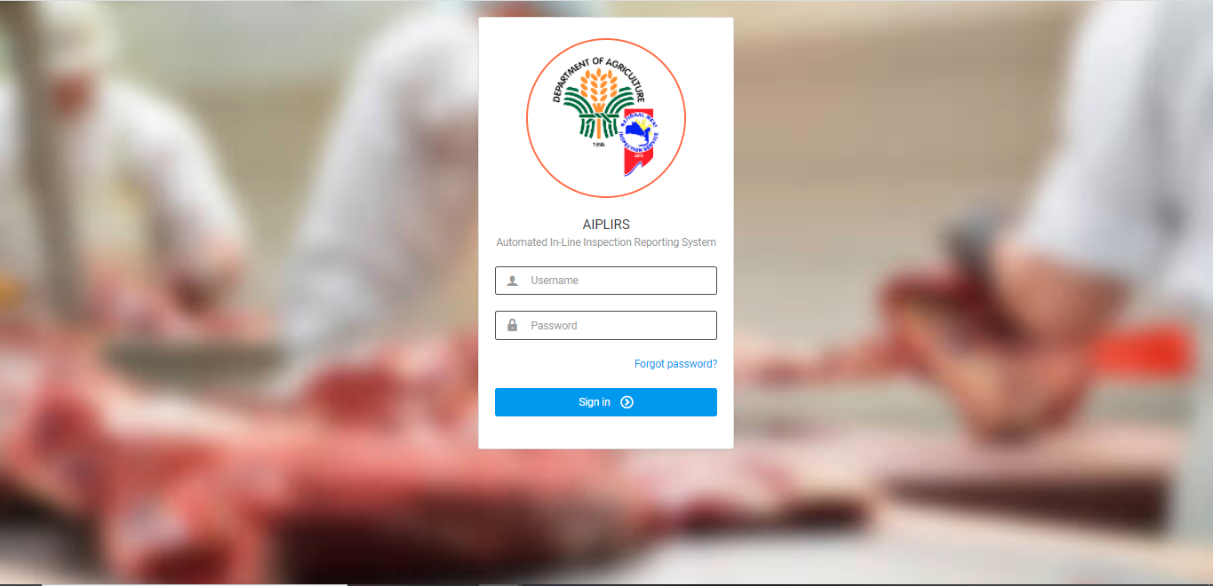

Daily Receiving Report

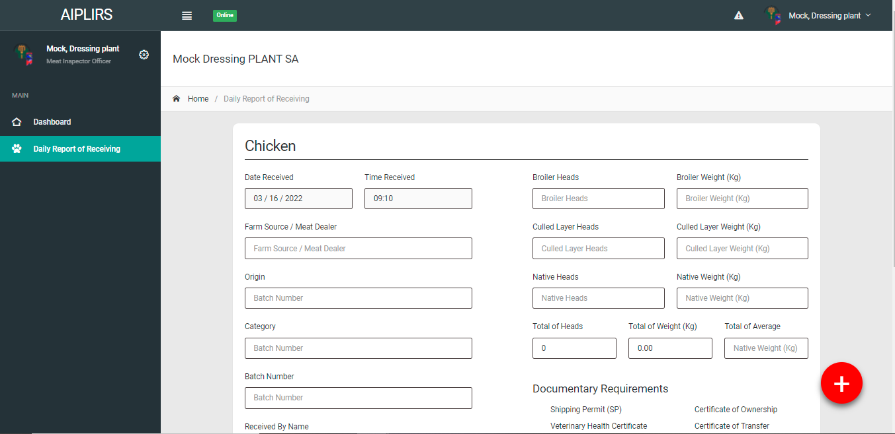

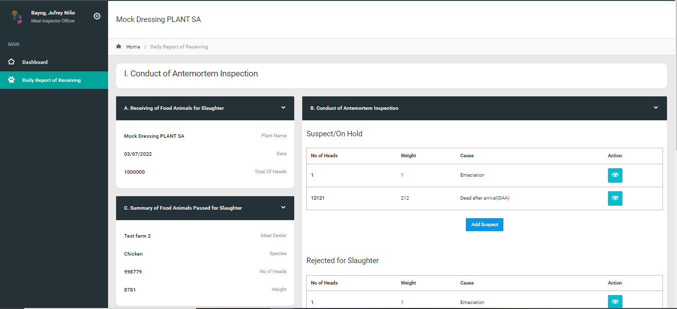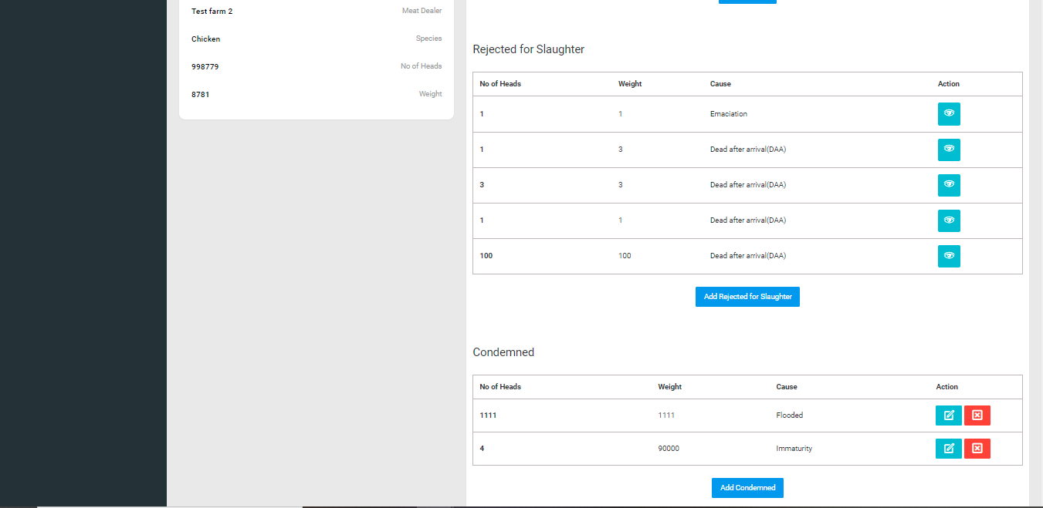

**AIPLIRS Swimlane**

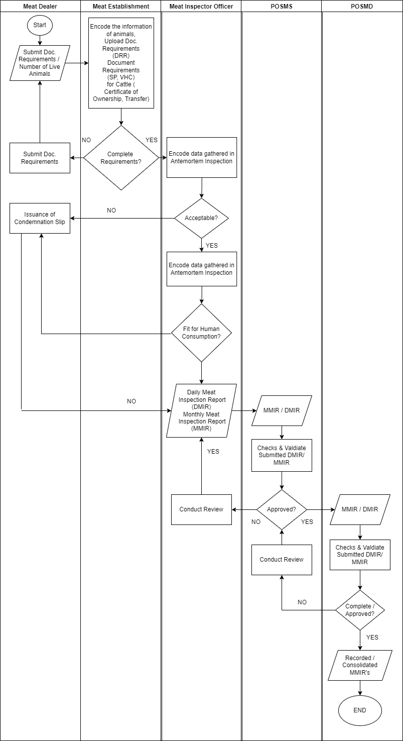

**AIPLIRS Database Structure**

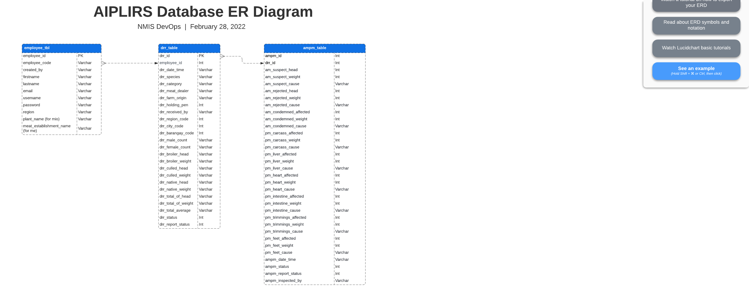

**AIPLIRS SIPOC Diagram**

|  |  |  |  |  |
| --- | --- | --- | --- | --- |
| **SUPPLIER** | **INPUT** | **PROCESS** | **OUTPUT** | **CUSTOMER** |
| Meat Establishment | Daily Receiving of Live Animals | Encoding of the number of heads, weight of the live animals received | No. of heads, weight of live animals | Meat Inspector Officer |
| Meat Inspector Officer | Antemortem Inspection data | Encoding for the Suspected / Rejected / Condemned Report | Antemortem Inspection Report / Food animals pass for Slaughter | Meat Inspector Officer |
| Meat Inspector Officer | Postmortem Inspection data | Encoding for the Carcass / Lungs / Liver / Heart / Intestines / Trimmings / Feet / Kidneys / Spleen Report | Postmortem Inspection Report | Meat Inspector Officer |
| Meat Inspector Officer | DMIR / MMIR | Submit Generate Report for DMIR / MMIR | DMIR / MMIR for approval | POSMS |
| POSMS | Validate DMIR / MMIR | Approve DMIR / MMIR Report, Inspected by Meat Inspector Officer | DMIR / MMIR Reports | POSMD |
| POSMD | Validate submitted report from the POSMS Regional Office | Approve DMIR / MMIR Report, Inspected by Meat Inspector Officer | Slaughter Reports | POSMD |